SUPERVISOR RECOMMENDATION

This is to certify that the report entitled “**OCR**”: Online Company Registration System**.**: submitted by AZ Kafle is prepared following my guidance as a requirement for the partial fulfillment of Bachelor of Science in Computer Science and Information Technology 6th semester E-governance Practical Exam.

………………….

SUPERVISOR:

Mr. Tekendra Nath Yogi

College of Applied Business and Technology

Gangahity, Chabahi

STUDENT DECLARATION

I hereby declare that the project work entitled **"OCR": Online Company Registration** submitted to College of Applied Business and Technology is a record of an original work done by me under the guidance of Mr. Tekendra Nath Yogi.

AZ Kafle

B.Sc. CSIT 6th Semester

College of Applied Business and Technology

Gangahity, Chabahil

# ACKNOWLEDGMENT

I would like to express my deepest gratitude to Mr. Tekendra Nath Yogi, whose guidance, support, and encouragement made this project possible. Your invaluable insights and feedback have been instrumental in the completion of this report.

Lastly, I extend my gratitude to College Of Applied Business and Technology for providing a conducive learning environment and the opportunity to undertake this case study.

# ABSTRACT

The Online Company Registration in Nepal is an e-governance system developed to simplify and enhance the efficiency of the company registration process. Built using ASP.NET MVC for the backend and HTML/CSS for the frontend, this system enables users to register companies online, submit necessary documents, and track their registration status. By providing a user-friendly interface and reducing the need for physical visits to the Office of Company Registrar, the system offers a more streamlined and accessible registration process. The project covers phases of analysis, design, implementation, and testing to ensure a robust and reliable platform. This system aims to deliver a seamless experience for users and an effective tool for managing company registrations in Nepal.

Keywords: Online company registration, E-governance, ASP.NET MVC, HTML/CSS, Document management, Registration tracking, Nepal, User-friendly interface, Company Registrar.

# Table of Contents

ACKNOWLEDGMENT i

ABSTRACT ii

Table of Contents iii

List of Figures v

List of Tables vi

CHAPTER1 1

INTRODUCTION 1

1.1 Introduction 1

1.2 Problem statement 2

1.3 Objective 2

1.4 Scope 2

1.5 Report organization 3

CHAPTER 2 4

BACKGROUND STUDYAND LITERATURE REVIEW 4

2.1 Background Study 4

2.2 Literature Review: 4

CHAPTER 3 6

SYSTEM ANALYSIS 6

3.1 Requirement Analysis 6

3.1.1 Functional Requirements 6

3.2.2 Non-functional Requirements 7

CHAPTER 4 8

SYSTEM DESIGN 8

4.1 Design 8

4.2 Class Diagram 9

4.3 Sequence Diagram 9

CHAPTER 5 11

IMPLEMENTATION AND TESTING 11

5.1 Tools Used 11

5.2 Testing 11

5.2.1 Unit Testing 11

5.3 System Testing 13

CHAPTER 6 14

CONCLUSION AND RECOMMENDATIONS 14

6.1 Conclusion 14

6.2 Future Enhancement 14

REFERENCES 16

APPENDIX 17

# List of Figures

Figure 1: UseCase Diagram 6

Figure 2: ER Diagram 8

Figure 3: Class Diagram 9

Figure 4: Sequence Diagram 10

Figure 5: Register Page 17

Figure 6: Registration Successful Page 18

Figure 7: Registration Form 19

Figure 8: Admin Page 19

# List of Tables

Table 1: Verifying The Login Credentials 11

Table 2: Verifying Registration form 12

Table 3: Verifying Home Page 13

# CHAPTER1

# INTRODUCTION

## Introduction

The "Online Company Registration in Nepal" project aims to develop an e-governance system to streamline the company registration process. The traditional method of company registration in Nepal involves multiple visits to the Office of Company Registrar (OCR), filling out numerous paper forms, and a lengthy approval process. This not only consumes a significant amount of time but also increases the workload on OCR officials, leading to inefficiencies and delays.

To address these challenges, the proposed e-governance system leverages modern web technologies, specifically ASP.NET MVC for backend development and HTML/CSS for frontend design. The system's primary goal is to provide a streamlined, user-friendly platform where users can register companies online, submit necessary documents electronically, and track the status of their applications in real time. This digital approach aims to eliminate the need for physical visits to the OCR, significantly reducing the time and effort required for company registration.

Key features of the system include:

* **Secure User Authentication**: Ensuring that only authorized users can access the system and perform registration-related activities.
* **Document Upload and Management**: Allowing users to upload required documents securely and manage them efficiently within the system.
* **Automated Notifications**: Keeping users informed about the status of their applications through automated email and SMS notifications.
* **User Dashboard**: Providing a comprehensive view of the application status, including any actions required by the user or OCR officials.
* **Role-Based Access Control**: Differentiating access levels and functionalities for various user roles, such as applicants, OCR officials, and system administrators.

## Problem statement

The current company registration process in Nepal is fraught with inefficiencies and complexities that create significant barriers for entrepreneurs and business owners. The primary issues identified in the traditional system are as follows:

* **Long and Complicated Process**: Registering a company requires multiple physical visits and lots of paperwork, causing delays.
* **Inefficiency:** Manual handling of documents leads to redundant work and mistakes.
* **Lack of Transparency**: Applicants can't easily track the status of their registration, leading to confusion and frustration.
* **High Costs**: Repeated visits and document handling add extra expenses, especially for small businesses and startups.
* **Limited Access**: People in remote areas find it difficult to access registration services.
* **Risk of Document Loss**: Physical documents can be lost or damaged, causing further delays.
* **Administrative Burden**: The current system places a heavy workload on OCR staff, taking time away from more important tasks.

## Objective

The primary objective of this project is to develop an e-governance system that enables users to:

* Register companies online.
* Submit required documents electronically.

## Scope

The scope of this project includes:

* Developing a web application for online company registration.
* Implementing features for document upload and management.
* Providing administrative tools for the Office of Company Registrar to manage registrations.
* Ensuring security and data integrity.
* Offering a user-friendly interface for ease of use.

## Report organization

As I divided my project into six different chapters, each representing a different development phase of the project. The chapters can be briefly discussed as follows:

**Chapter 1: Introduction**

In the first section, we present an outline of the e-governance system for online company registration in Nepal. It describes the problem that the system needs to solve and provides insights about the objectives, scope, and limitations of the system.

**Chapter 2: Background Study and Literature Review**

The second chapter focuses on the background study of the current scenario of the company registration system in Nepal. It also reviews various literature based on research conducted by others in the field of e-governance and online registration systems.

**Chapter 3: System Analysis**

The third chapter describes the Requirement analysis, functional requirements, non-functional requirements, and feasibility study (technical and operational feasibility) for the proposed system.

**Chapter 4: System Design**

In the fourth section, we provide detailed descriptions and diagrams for the system's design. This chapter includes use case diagrams, ER diagrams, DFD/Class diagrams, and sequence diagrams. It also gives basic information or details about the algorithms used.

**Chapter 5: Implementation and Testing**

The fifth section shows the implementation of our system using various technologies. We describe each designed functionality and its purpose. This chapter includes unit and integration testing of the components and summarizes the results of the project.

**Chapter 6: Conclusion and Future Recommendations**

This chapter contains the conclusion of the project and provides further recommendations for enhancing the system in the future

# CHAPTER 2

# BACKGROUND STUDYAND LITERATURE REVIEW

## 2.1 Background Study

The Office of Company Registrar (OCR) in Nepal has traditionally operated using a manual process for company registration, which involves multiple visits to the office, significant paperwork, and lengthy processing times. This system has resulted in inefficiencies, including time-consuming procedures, administrative burdens, and a lack of transparency. Applicants often face delays and difficulties in tracking the status of their registration, which can be particularly challenging for those located in remote areas of Nepal. The manual system also incurs substantial administrative costs and increases the risk of errors due to manual data entry and document handling.

An online company registration system offers a solution to these challenges by leveraging e-governance principles. E-governance utilizes information and communication technologies (ICT) to streamline and improve public services. By implementing an online registration platform, the OCR can significantly enhance efficiency, allowing for quicker processing of applications and reduced administrative workloads. This shift to digital platforms also promotes greater transparency, as applicants can track their registration status in real-time. Moreover, it increases accessibility for users across the country, eliminating the need for physical visits to the OCR office and thereby addressing geographical barriers.

Globally, similar e-governance initiatives have demonstrated substantial benefits. For example, Singapore’s Business Registration System and India’s MCA21 project have successfully automated their company registration processes, resulting in faster, more efficient service delivery. These systems highlight the potential for digital transformation to not only streamline administrative processes but also to reduce costs and improve service accessibility. In the context of Nepal, an online registration system aligns with these best practices and offers a promising solution to modernize the OCR's services, enhancing overall efficiency and user satisfaction.

## 2.2 Literature Review:

The shift towards e-governance has been a pivotal development in modernizing public administration globally. Various studies have highlighted the benefits and challenges of implementing online government services, particularly in the domain of company registration. According to Heeks (2001) [1], e-governance can significantly enhance administrative efficiency, transparency, and accessibility of public services. This is particularly relevant for developing countries like Nepal, where traditional bureaucratic processes often impede timely service delivery and accessibility.

Studies on the implementation of e-governance in different countries provide valuable insights into the potential advantages and obstacles. For instance, Singh et al. (2008) examined India's MCA21 project [2], which digitized the company registration process. The study found that the digital system reduced processing times, minimized errors, and increased transparency, leading to higher user satisfaction. Similarly, in Singapore, Tan et al. (2010) [3] analyzed the impact of the Business Registration System and reported significant improvements in service efficiency and user convenience. These cases underscore the transformative potential of e-governance in streamlining administrative processes and enhancing service delivery.

However, the literature also identifies several challenges associated with the adoption of e-governance systems. Gupta and Jana (2003) [4] highlighted issues such as digital divide, data security, and resistance to change among users and officials. These challenges are particularly pronounced in developing nations where infrastructure and digital literacy may be limited. In the context of Nepal, Sharma and Shrestha (2018) [5] emphasized the importance of addressing these barriers through comprehensive training programs, robust cybersecurity measures, and efforts to increase digital literacy. Ensuring user-friendly interfaces and reliable technical support is also crucial for the successful implementation of e-governance systems.

# CHAPTER 3

# SYSTEM ANALYSIS

## 3.1 Requirement Analysis

## 3.1.1 Functional Requirements

The functional requirements define the specific behaviors or functions of the system. For the Online Company Registration System in Nepal, the primary functional requirements include:

* **User Registration:** The system must allow users to register with their personal and company details.
* **Company Registration:** Users should be able to register a company by providing necessary details and uploading required documents.
* **Document Management**: The system must manage and store the documents securely.
* **Administrative Functions:** Admins should have functionalities to review, approve, or reject company registration applications.

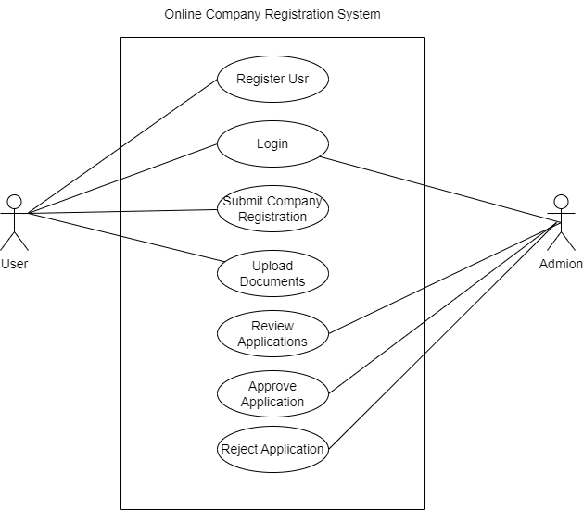

Figure 1: UseCase Diagram

## 3.2.2 Non-functional Requirements

The non-functional requirements specify criteria that can be used to judge the operation of the system, rather than specific behaviors. They include:

* **Performance**: The system should handle multiple simultaneous users without performance degradation.
* **Security**: Sensitive data must be protected through encryption and secure access controls.
* **Usability**: The user interface should be intuitive and easy to navigate.
* **Reliability**: The system should be available 99.9% of the time and have mechanisms for backup and recovery.
* **Scalability**: The system should be able to scale to accommodate future growth in users and data.
* **Maintainability**:Implement automated testing and continuous integration to catch and fix bugs quickly.

# CHAPTER 4

# SYSTEM DESIGN

The system design phase of the Online Company Registration system focuses on creating a comprehensive architecture that supports the functional and non-functional requirements outlined during the analysis phase. This chapter includes the detailed design of the system through various diagrams and descriptions that illustrate the overall structure and components of the system.

## 4.1 Design

The ER diagram for the online company registration e-governance system:

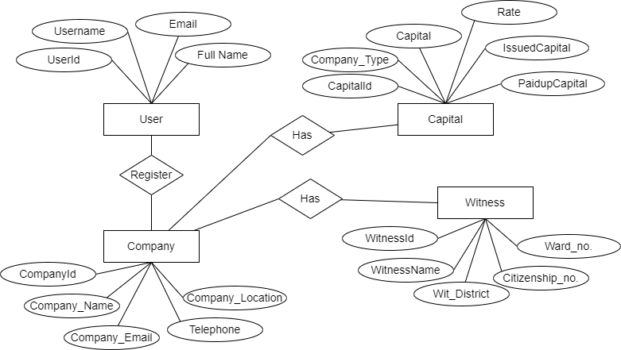

Figure 2: ER Diagram

## 4.2 Class Diagram

The Class Diagram for the online company registration e-governance system:

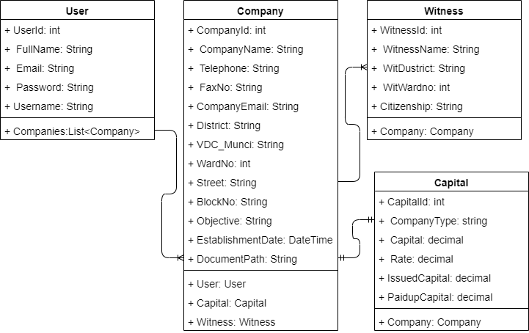

Figure 3: Class Diagram

## 4.3 Sequence Diagram

The Sequence Diagram for the online company registration e-governance system:

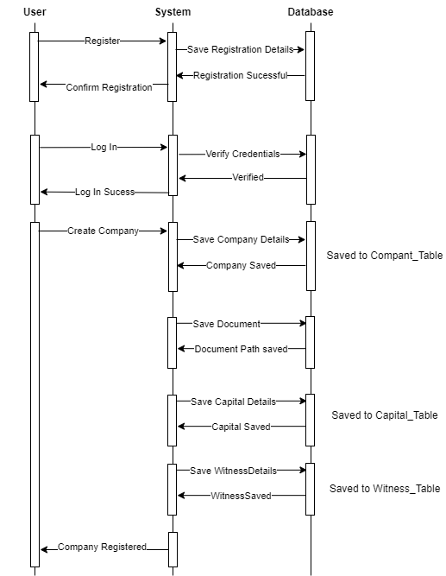

Figure 4: Sequence Diagram

# CHAPTER 5

# IMPLEMENTATION AND TESTING

## 5.1 Tools Used

Multiple tools were employed to create the various diagrams and charts featured in this report, including use case diagrams, sequence diagrams, flowcharts, and class diagrams. Among these, Draw.io was the most commonly used, offering a versatile and user-friendly platform for depicting complex system interactions and structures.

* **Front-end:** Html, CSS, JavaScript
* **Back-end:** .NET
* **Database:** MSSQL
* **IDE:** Visual Studio
* **Framework:** ASP.NET MVC
* **Browser**: Google Chrome,Edge

## 5.2 Testing

## 5.2.1 Unit Testing

Table 1: Verifying The Login Credentials

|  |  |  |  |  |
| --- | --- | --- | --- | --- |
| **TC_ID** | **Test case description** | **Expected**  **Output** | **Actual Output** | **Remarks** |
| TC_01 | Verify if user is able to login with invalid credentials. | An error  Message should be displayed. | An error  Message is displayed. | Pass |
| TC_02 | Verify if user is able to login with valid credentials. | The user should see the successful login and should be  redirected towards the  Home page. | User is able to login. | Pass |

Table 2: Verifying Registration form

|  |  |  |  |  |
| --- | --- | --- | --- | --- |
| **TC_ID** | **Test case description** | **Expected Output** | **Actual Output** | **Remarks** |
| TC_03 | Enter value that does not follow Email format | An error Message:  “Invalid Email  Format” | User should  receive the error Message. | Pass |
| TC_04 | Enter password ranging less than 4 characters | An error Message:  “Password must be 4 characters long” | User should receive the invalid message. | Pass |

## 5.3 System Testing

Table 3: Verifying Home Page

|  |  |  |  |  |
| --- | --- | --- | --- | --- |
| **TC_ID** | **Test case description** | **Expected Output** | **Actual Output** | **Remarks** |
| TC_01 | Company registration with valid data. | User should be able to Submit the company registration form unless user submit form with missing required fields. | User is able to  Submit the new company registration form. | Pass |

# CHAPTER 6

# CONCLUSION AND RECOMMENDATIONS

## 6.1 Conclusion

The development of the online company registration system for Nepal's Office of Company Registrar (OCR) represents a significant advancement in e-governance, aimed at streamlining the company registration process. This project has effectively addressed the primary objectives of creating a more efficient and user-friendly platform, reducing the need for physical visits to the OCR, and improving overall accessibility for entrepreneurs. Through the use of ASP.NET MVC for the backend and HTML/CSS for the frontend, the system provides a robust and scalable solution that includes essential features like document upload and real-time status tracking. The successful implementation of this project has led to an efficient registration process, enhanced user experience, and improved data management.

## 6.2 Future Enhancement

**User Experience Improvements**

One significant enhancement would be the development of a mobile application. This app would provide users with the convenience of registering and managing their company information directly from their smartphones or tablets. Additionally, refining the user interface to be more intuitive and accessible will improve overall user satisfaction.

**Feature Expansion**

Several features could be added to the system to increase its functionality. For example, incorporating a document verification system using OCR technology can automatically verify and extract information from uploaded documents, reducing manual errors. Integrating an online payment gateway will facilitate secure transactions for registration fees, while an automated notification system will keep users informed of their registration status via email and SMS.

**Integration with Other Government Services**

Developing integrations with other government services will create a more comprehensive e-governance platform. By allowing data sharing via APIs and integrating with departments such as tax offices and social security, the system can offer a seamless exchange of information and streamline related processes.

# REFERENCES

1. Heeks, R. (2001). Understanding e-Governance for Development. Institute for Development Policy and Management, University of Manchester.
2. Singh, A., Srivastava, S., & Srivastava, R. (2008). e-Governance in India: A Case Study of MCA21. Electronic Government, an International Journal, 5(2), 123-138.
3. Tan, C. W., Pan, S. L., & Lim, E. T. (2010). Managing Stakeholder Interests in e-Government Implementation: Lessons Learned from a Singapore e-Government Project. Journal of Global Information Management (JGIM), 18(1), 39-59.
4. Gupta, M. P., & Jana, D. (2003). E-government evaluation: A framework and case study. Government Information Quarterly, 20(4), 365-387.
5. Sharma, S., & Shrestha, P. (2018). E-Governance in Nepal: Prospects and Challenges. Journal of Development Innovations, 2(3), 45-56.

# APPENDIX

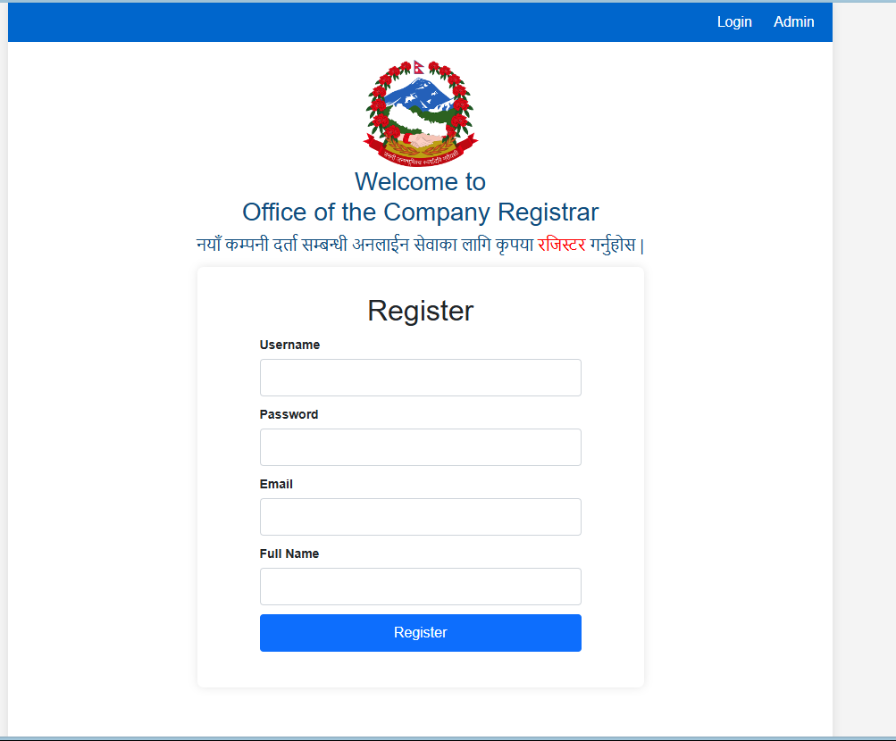

Figure 5: Register Page

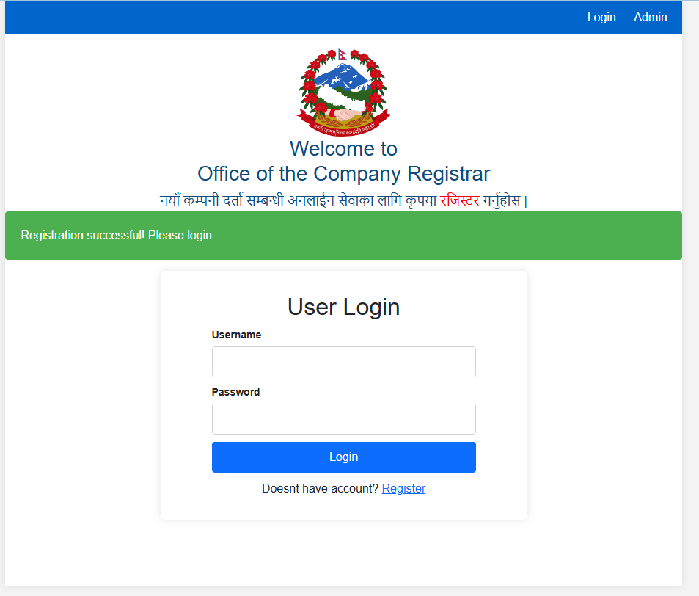

Figure 6: Registration Successful Page

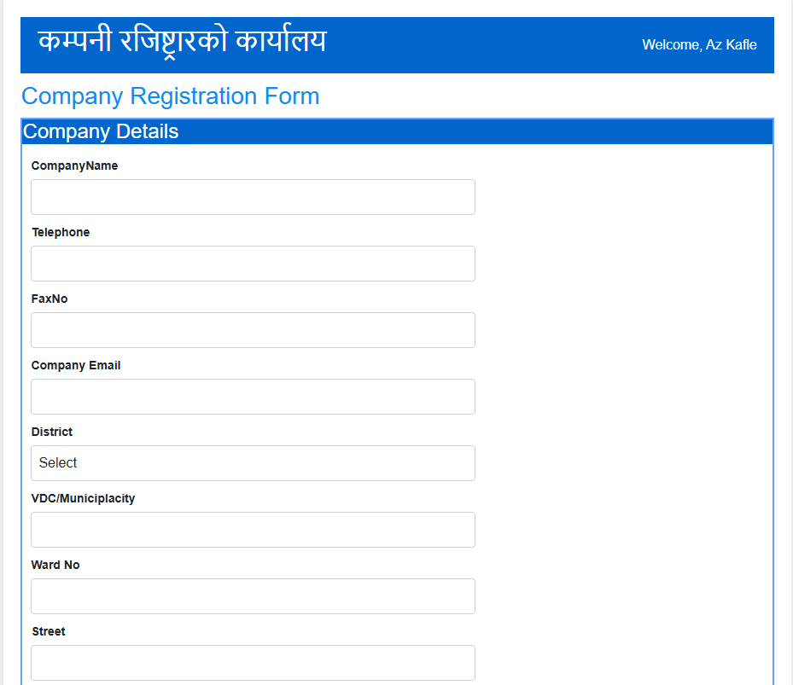

Figure 7: Registration Form

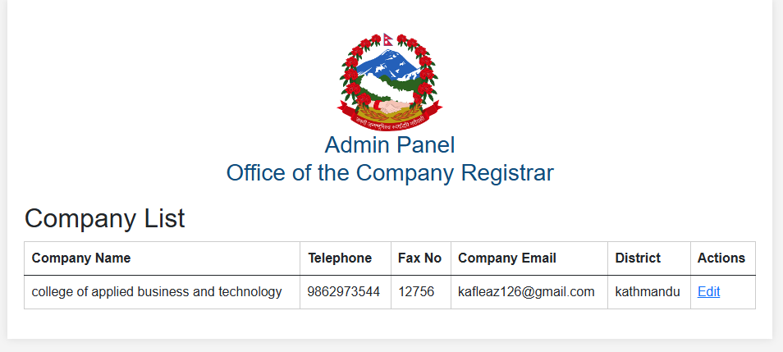

Figure 8: Admin Page